HOVERCRAFT WORKLOG

19th May,2024

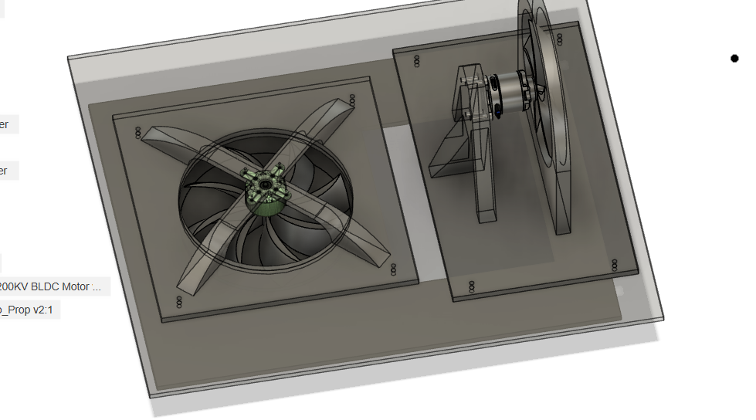

*Figure 1: General shape of the hovercraft*

I made the push fan motor stand, minimized the size of the design, and I need to 3d print as well as laser cut. I need to come up with a way to fixate the skirt.

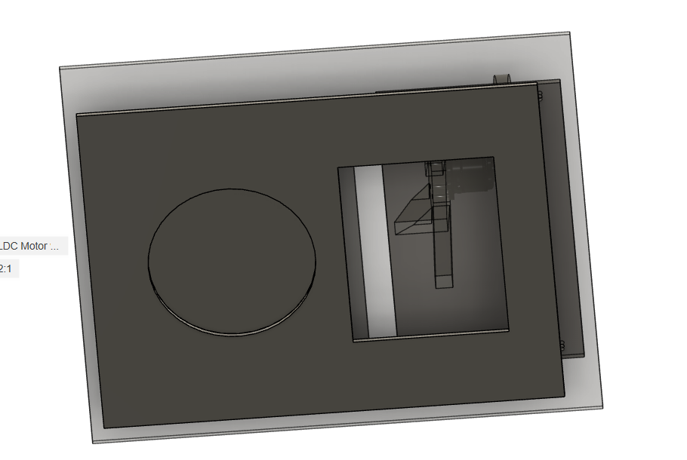

*Figure 2: bottom view of the prototype*

I also made a hole at the bottom. The bottom layer’s design is bad, so I need to redesign it. In the future I can put a control device on the second layer like a wheel or something. Still working on the way to connect second layer to first layer. One of the ideas I got is to make a trench that sticks the second layer to the first one, without any screws to fix it.

I just finished trying to print the models in 3d. I came up with a way to print the layer connector (like slides), but they might be too big, so I must make sections of them.

I printed both the fans. I am still printing the motor holder in the lab. The push fan holder’s too big, so I intend to cut them up into bits, then laser cut the two layers. The printers both must fail at least once, and they both just do not stick to the printing bed. Besides that, I also made a mess because of it not sticking. The motor holder printing keeps on not sticking to the printing table 2 more times. However, I got too tired so I decided to just trust that it would stick to the bed. Well, it seemed good after I left. The other one printed the fan quickly, but breaking the support was very tiresome.

I checked the prints today, some of them holes are too small, so I must drill through it. I need to use the thread insert into the float motor holder.

New idea: instead of threaded insert into the 3d prints, use nuts and bolts instead. This solution is questionable, as it increases the weight of the hovercraft. Also need to ask Jasmine from Design Factory, who made the drone.

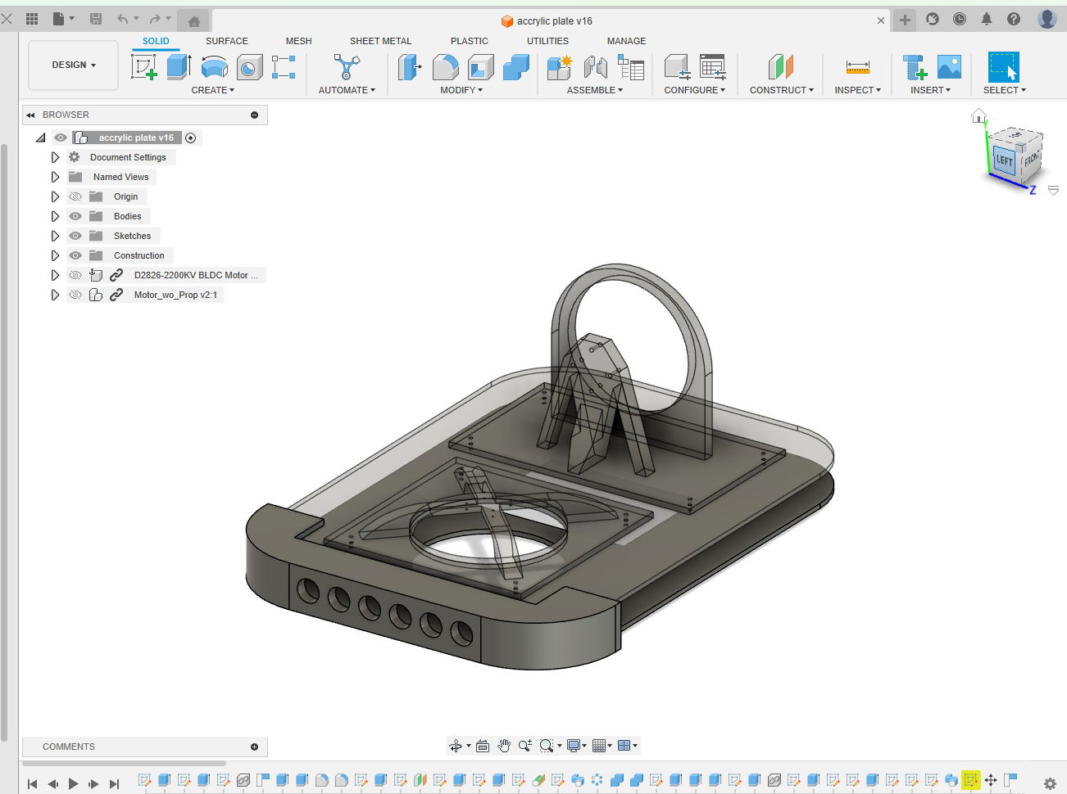

*Figure 3: edge of the hovercraft are rounded off.*

31st May,2024

Push fan holder printed. Motor tested and it is powerful. If I want to test out the battery, I will use the devices at the electro shop. 5V in ESC is an output to drive micro controllers that takes energy from battery. Everything electronically works fine. The 3D printed fan broke.

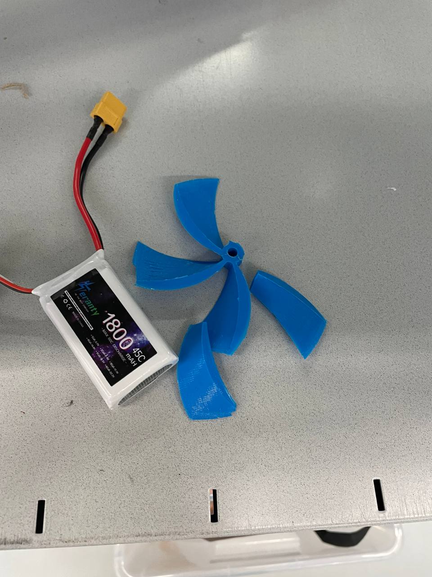

*Figure 4: broken fan and battery*

I need to remake and redesign the fan, need to put some holes for nuts in the sliding trays. Do I even need to make the sides? Oh yeah also need to make a place to hold the skirt.

June 13th,2024

I will just tape the skirt onto the hovercraft. The design is done. It is time to print then assemble it.

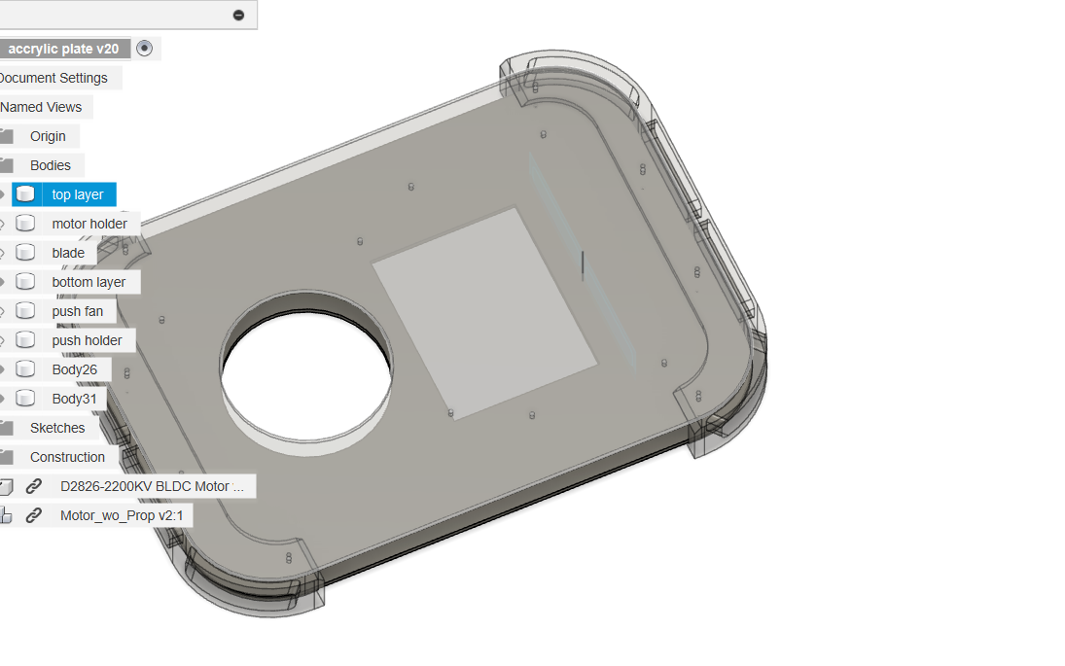

*Figure 5: top view of the hovercraft*

I should buy a propeller instead, because they are designed perfectly for air flow. If I want to print it, print in PLA but it is quite hard. Printing at lower layer height kind of allows designs to be printed at a steeper angle, though it comes with a cost of high printing time (usually double). If the holder printing fails, try raising the heat of the printing bed, as it might be curved because of expansion.

Also, I should thread insert inside of the propeller if I am 3d printing it, as then the fan will not need friction to stay attached to the motor.

A small design or printing error in a propeller will affect the efficiency of the fan a lot. That is why it is suggested to buy it then design the prototype around the propeller instead. It feels like the first design will fail, but a lot of things are learnt.

Next thing, toroidal application. I should maybe use Openscad to generate a toroidal fan. Two options: back to the drawing board or continue the current one.

Wild theory, the pushing fan spins so it has some centrifugal force.

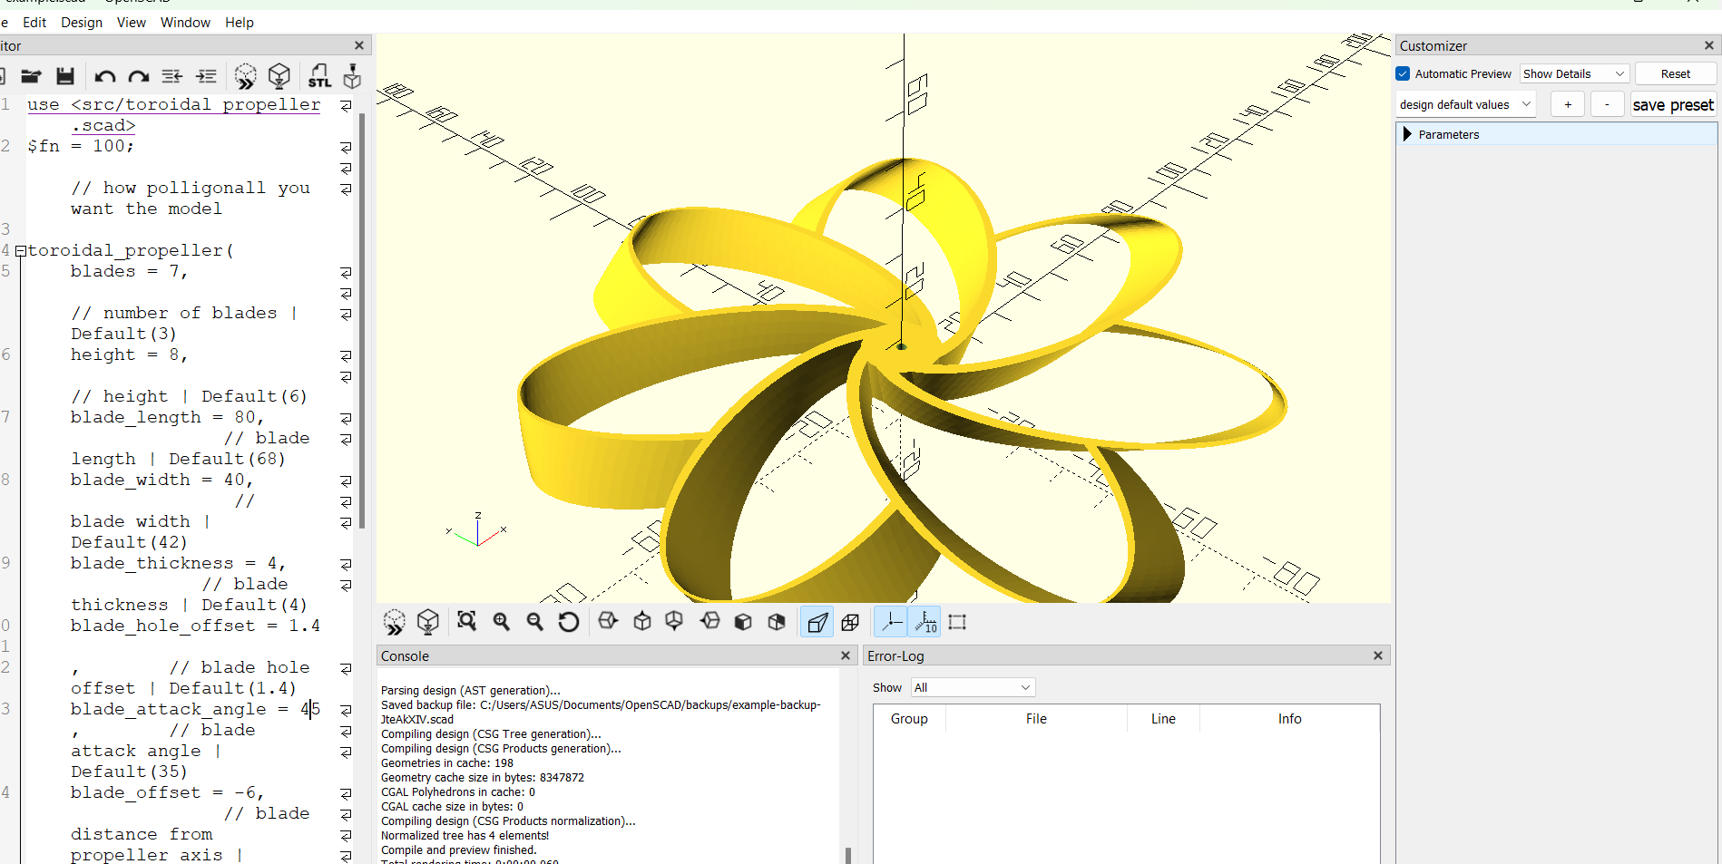

*Figure 6: Openscad toroidal fan generator*

June 16th, 2024

I managed to install the push fan holder.

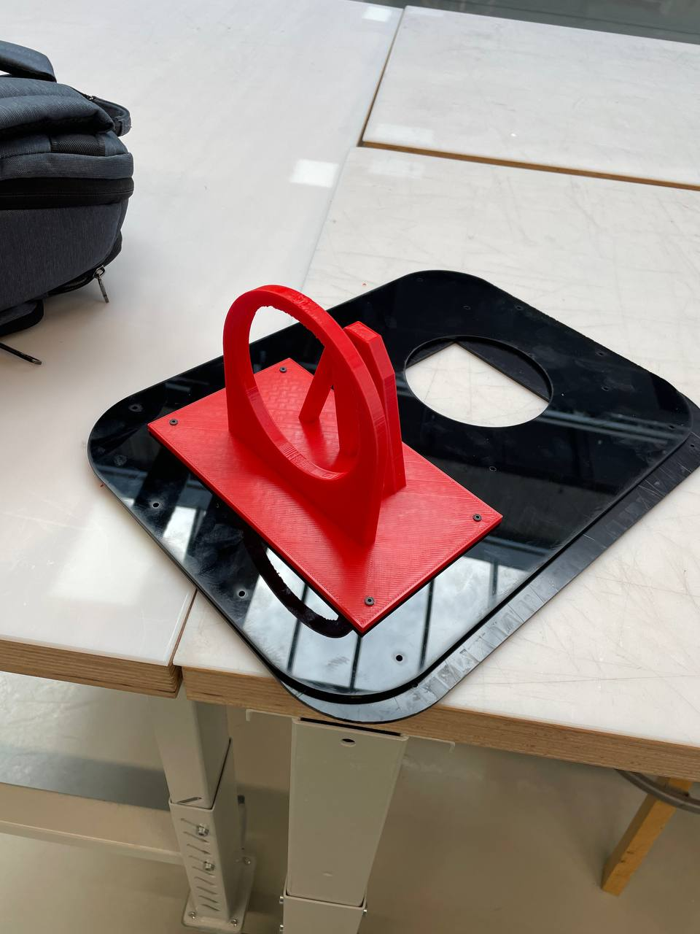

*Figure 7: the push fan holder is installed on the laser cut acrylics*

The lift holder is too small. Drilling through the hole might destroy the 3d print’s walls. I need to print it again.

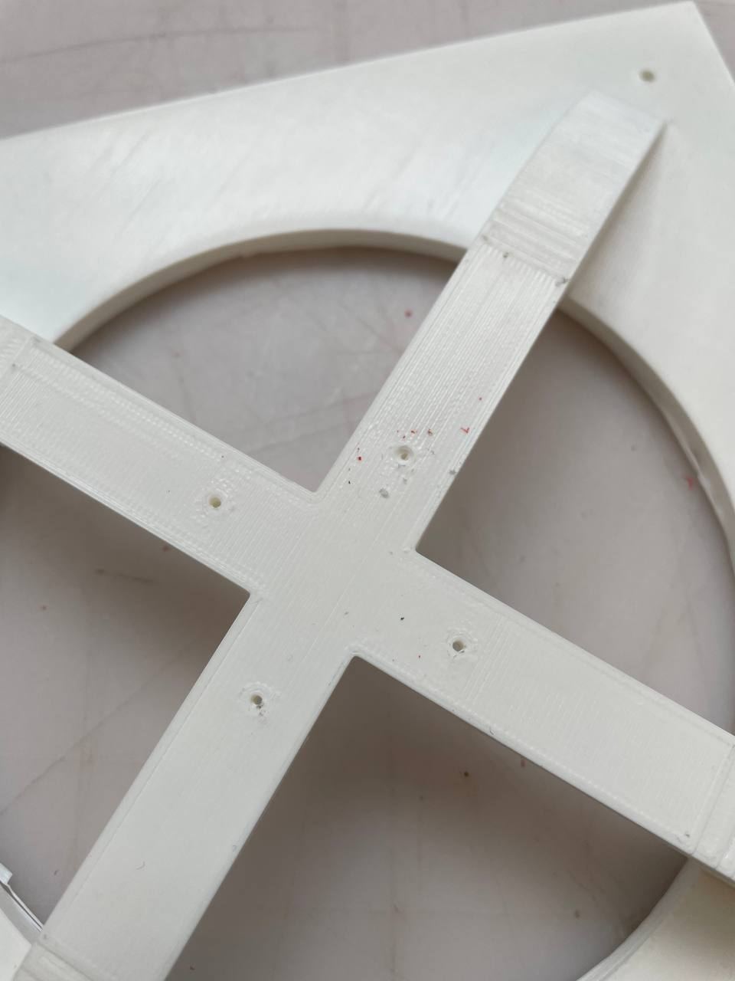

*Figure 8: impeller motor holder’s hole being too small*

An asymmetrical toroidal impeller would be an interesting design to minimize noise.

June 24th, 2024

Should have made the floating fan heads up instead of being upside down, it gives more room to design a fan and makes it better to have room to push air.

Now I need to print the toroidal fan because it is too big, then I need to bring my plastic bag and cook up the skirt. I must remove the bottom layer then put it outside of the two holders, because it was too short for the impeller and the motor.

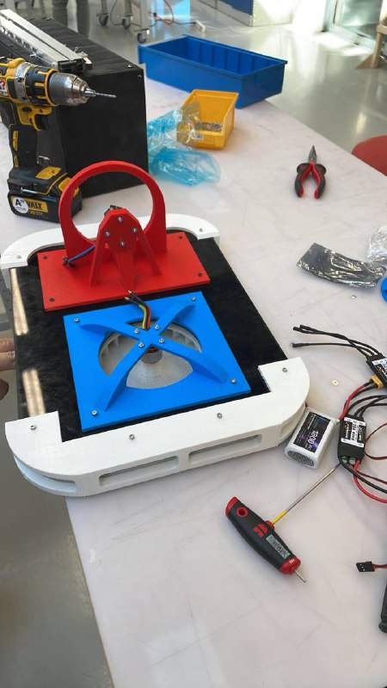

*Figure 9: completed assembling the frame hovercraft*

I finished making the skirt around. The tape works, though it needs a field test to see if the skirt actually works or not. The push fan needs to be printed again as it is still too big.

July 1st, 2024

I finished taping the skirt, I still need to test if it hovers or not. I should get IMU to use as measuring unit.

Use Brushless Servo, it works with the ESC and controls it. Servo library does not work. Tighten the screws, the motor is strong so use washers as well. The impeller needs to be screwed in. It now touches the bottom layer, so the impeller worked for a bit. Need to note that the air blow from impeller is quite efficient. Also, I should make a frame for the skirt so that I don’t have to tape the skirt on again

July 23rd, 2024

I redesigned most of them but have not printed them yet. I need to sand the impeller.

I removed the skirt. The fan screws fit but somehow, it’s too short. Use cardboard for prototyping

August 28th, 2024

I might have busted the fan motor. Probably I screwed in too strongly, so it busted the magnetic coils inside. The ESC worked fine. However, the impeller did not fit, as it fully touches the top or bottom layer, creating friction stopping the impeller from spinning. because the size difference between the actual motor and the model I downloaded online was different.

Because the bottom of the hovercraft is not fully in contact with the ground while taking off, it creates no pressure. The weight of it is 2.7kg, which might take part in keeping the hovercraft grounded.

Redesigning:

-Need space to store battery

-ESC needs ventilation

-Not too big

-Bottom layer needs to be flat

-Easy to put skirt on

-Rudders on the rear+servo

-Space for actuator

October 22nd, 2024

The actuator might fall over. How to secure?

I checked whether the servo has enough torque to push the actuator, and it seems like it does.

At first, because of the size of the actuator, I decided to make the actuator stick out of the upper deck of the hovercraft, and the servo motor being located on the battery storage. To turn spinning momentum of the servo into up and down motion, I created spur gear and gear rack. After finishing the actuator, I realized that the hovercraft needs to be airtight, and the actuator is located such that it creates a hole in the hovercraft. I had to relocate both the up-down functionality, the actuator, and the servo motor down. That proves nearly impossible as the actuator is very large. I had to increase the height of the hovercraft by 7mm. At resting position, the hovercraft needs to lay perfectly on the ground so that when it is turned on, the air evenly escapes on all sides of the hovercraft, instead of focusing on one side so that it creates lift. This will inevitably increase the weight of the hovercraft, so I am unsure if the impeller pushes enough air to make the hovercraft float. I decided to offset the components (battery and the Arduino in the cargo) further from the center to make more room for the actuator.

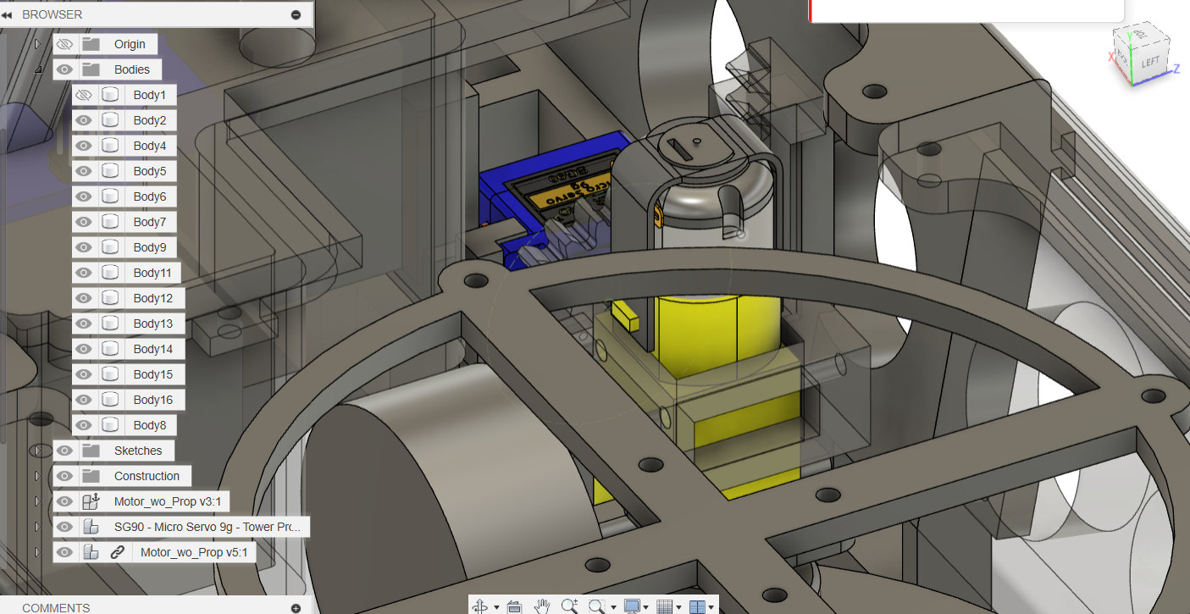

*Figure 10: actuator of the hovercraft*

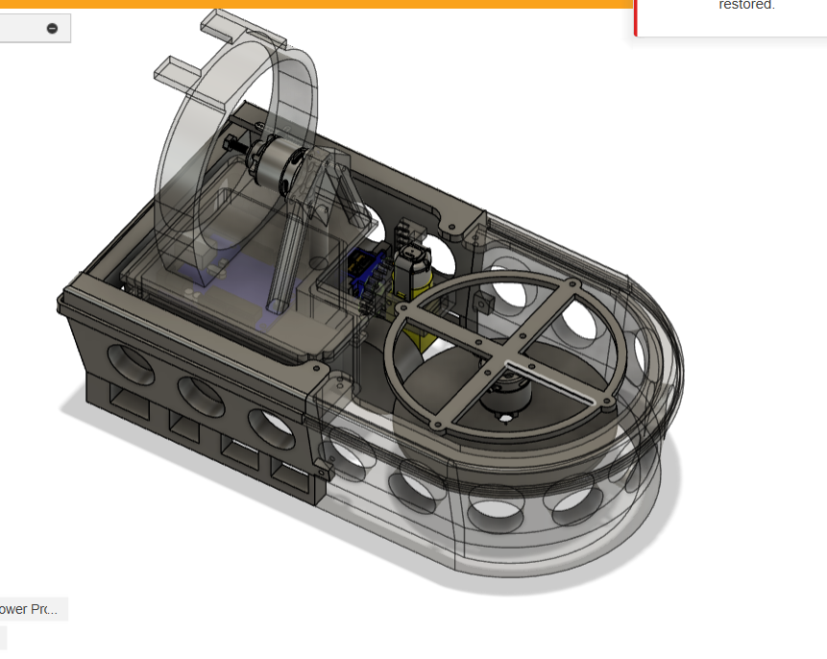

*Figure 11: the entire hovercraft, remodeled*

November 1st, 2024

I tried designing the rudder using principle of least action, but I found drawing cycloids on Fusion difficult, I decided to just approximate the cycloid. I finished some small parts of the hovercraft, but haven’t finished the entire mechanical part yet, as my laptop broke. I also must move the skirt clipping bar at the bottom 2mm upwards, as the clipper is 2mm thick.

*Figure 12: finished parts of the hovercraft*